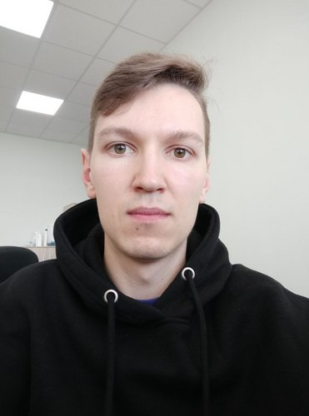 |  | Makarov Mikhail  Male, 29 years, born on 6 May 1993  +7 (965) 1567895  mikhail.makarov@phystech.edu — preferred means of communication  Reside in: Moscow  Citizenship: Russia, work permit at: Russia  Ready to relocate, ready for business trips
Desired position and salary
Frontend developer
Specializations:
— Programmer, developer
Employment: full time
Work schedule: full day
travel time to work: any
Work experience
August 2022 — till now |  | Flat Software  Frontend developer  Website development and support
August 2016 — till now |  | JSC MERI  Senior Researcher  Theoretical and numerical simulation of various integrated optics devices using Comsol Multiphysics software, scientific writing.
Education
Master
2016 |  | Moscow Institute of Physics and Technology (state university)  Faculty of Physical and Quantum Electronics, Applied Mathematics and Physics
Bachelor
2014 |  | Moscow Institute of Physics and Technology (state university)  Faculty of Physical and Quantum Electronics, Applied Mathematics and Physics
Professional development, courses
2021 |  | FreeCodeCamp  FreeCodeCamp, JavaScript Algorithms and Data Structures
2020 |  | Coursera  MIPT and Yandex, Разработка интерфейсов: вёрстка и JavaScript
Key skills
Languages |  | Russian — Native  English — B1 — Intermediate
Skills |  | Vue 2/3 Pinia Element-plus Vuex JavaScript Git HTML5 CSS HTML CSS3 Node.js OOP Webpack Ajax Sass SCSS npm Express.js Bootstrap Jenkins Comsol Multiphysics Scientific writing БЭМ
Additional information
About me |  | My name is Mikhail Makarov. Recently, I changed my career direction to front-end development due to difficult conditions and lack of prospects in the field of silicon photonics in Russia. Therefore, my academic results are Master's and Bachelor Degrees in Applied Mathematics and Physics. But when I realize that I want to became frontend developer, I took courses of HTML, CSS, SCSS and JS from JSC Yandex and MIPT. Then I did some freelance orders to create layouts of email newsletters and simple websites. It was a good experience, but I wanted to go further and got skills with Vue 2/3 framework and a pack of side technologies: webpack, pinia, npm, git and so on. Currently I work remotely as a frontend developer in Flat Software.  Hard skills: Vue, Javascript, SCSS, CSS, HTML, БЭМ, webpack, pinia, vuex, vue-cli, git, npm, Node.js, Express.js, Bootstrap  Soft skills: independence, working in team, flexibility, scientific writing.  Unfortunately I can't show my latest projects due to the NDA, below are just the projects I did during my studies:  1) https://github.com/MikhailErnstovich/violet-layout  2) https://github.com/MikhailErnstovich/baikal-main  3) https://github.com/MikhailErnstovich/sublime-web-store  Course certificates:  1) https://www.coursera.org/account/accomplishments/specialization/KKPTF2MJ95M8  2) https://www.freecodecamp.org/certification/fcc0fb53d16-e07a-4e60-9166-8b61529a2b34/javascript-algorithms-and-data-structures  My scientific papers:  https://www.researchgate.net/profile/Mikhail-Makarov-6

